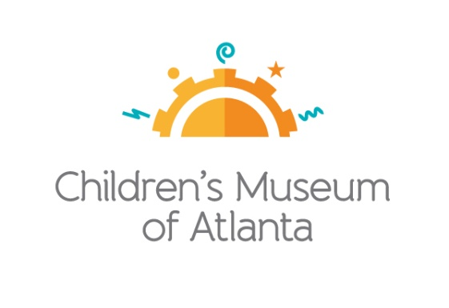

CONTACT
Alison Wentley
BRAVE Public Relations
404.233.3993
awentley@emailbrave.com

*MEDIA ADVISORY*
Family Free Day returns to Children’s Museum of Atlanta on November 13
PNC Foundation, The Coca-Cola Foundation and CareSource fund harvest-themed day of programming

ATLANTA (October 22, 2019) – Families are invited to visit Children’s Museum of Atlanta free of charge during Family Free Day on Wednesday, November 13. With programming specifically centered around the fall harvest season and nutrition, kids will have the opportunity to create plates of colorful balanced meals in the Art Studio, learn about how food provides fuel and energy at the Science Bar, make simple machines that are used on the farm in the Build It Lab and more. Made possible by the support of the PNC Foundation, The Coca-Cola Foundation and CareSource, the three sessions will also offer the chance for kids to explore the Museum’s six permanent, interactive exhibits as well as Curious George™: Let's Get Curious which runs through January 5, 2019.

To guarantee entrance, families must pre-register online, beginning at 7 a.m. on Tuesday, November 12 for one of the three sessions. In order to welcome as many guests as possible, families may not register for multiple sessions.

WHAT: Family Free Days
Georgia families are invited to experience a harvest-themed admission-free visit to the only education venue of its kind in Atlanta

WHEN: Wednesday, November 13
Session One: 10 a.m.-12:30 p.m.
Session Two: 1-3:30 p.m.
Session Three: 4-6:30 p.m.

WHERE: Children’s Museum of Atlanta
275 Centennial Olympic Park Drive, NW
Atlanta, GA 30313

HOW: For more information or to register, visit childrensmuseumatlanta.org/familyfreeday.

For more information or to support Children's Museum of Atlanta, visit childrensmuseumatlanta.org
or call 404.659.KIDS [5437]

###

